Greetings One & All

Circular 60/16 July 2016

July already and I see the last Circular was in January! Does time speed up the older we get? – it seems so to me. But (of course) I have my excuses ready. In the early part of the year Judy and I are heavily involved in the Kalk Bay Concert in the park – a great fund raiser for park maintenance. Every year when it’s over and the money has been banked I say ‘Never again’ – until next time.

Then we went on a wonderful road trip via George to my home town – good old East London. We stayed with Judy’s cousin, Kate and family came down from Jbg and we had a wonderful time. Of course we saw the EL Flemmers and had a mini reunion at Nolan and Jenny’s house on the banks of the Nahoon. Wonderful to catch up with everyone again and pity my dear cousin Dan had fled the scene by the time we got there. Here we see the happy throng.

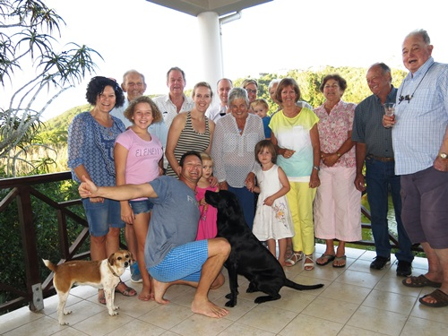

From EL we headed back down the coast, stopping off in PE and taking the opportunity to visit Kit and Carol Carter on their farm. All in all a great trip.

Then it was back home and as these things happen a string of visitors – I think about 20 in 3 weeks – so it was good to leave for our Greek getaway mid-May from whence we have just returned.

And so to matters of business. Last time I bemoaned the fact that these circulars went out into the ether and I am never quite sure if anyone reads them. So thank you to the people who wrote back saying they did indeed. It was good to hear from Jim Rous, Paddy Briant, Dan Flemmer and Jill Moffett. Jill (daughter of Gwynneth Flemmer) told me of the good news of the arrival of their first great grandchild Lee Ann Du Plessis on 17th July 2015. This is wonderful and are there any other great grannies out there?

I was sorry to get the news that John Mast (son of Barbara Anna Flemmer) had died aged 80 on 20th April 2016. Our sympathies to Athalie and all of his many descendants. John was always keen on family history matters and will be missed. You can read a bit about him on the Flemmer Family websitehttp://www.flemmerfamily.co.za/#!50/c20k3

Fay does a wonderful job sending out these circulars but in January we had an unusual number of mails bouncing back. We don’t like to see people fall off the list so if you have correct addresses for these people please mail Fay cancun@icon.co.za

MIAs
Ballentine Kim kim@ballantineinc.co.za, Flemmer Warren Flemme_W@mtn.co.za, Gilfillan Ted gilfilec@telkomsa.net, Howard-Browne Lorna bazilhb@gmail.com, McBean Margie & Duncan mcbean@telkomsa.net, Mast Noel & Jo noelmast1@afrihost.co.za, Teeton Carol & Billy bteeton@woodridge.co.za, Turner Sandy turner@intekom.co.za, Von abo Olaf o.vonabo@netgroup.co.za, Rainier-Pope Mark MRPope@anglogold.ibex.com, Rainier-Pope Mark MRPope@anglogold.ibex.com, Nolan- Neylan Hannah hannah@hmn.co.uk

Tracing our roots is one of the biggest hobbies worldwide now and the internet has made it possible for millions around the world to look for their ancestors. But we know many people are hesitant to start the journey or don’t know how to begin. Fay has decided to put her years of experience to good use and with a friend is offering her services to help people get started or to do research for them. Why not contact Fay?
Who were they?
Let us bring your ancestors to life.
Our research is sensitive, confidential & competitively priced.
Contact
Mel 021 976 2186 melcross77@gmail.com
0r
Fay 072 040 209
cancun@icon.co.za

Keep in touch and send me your family news!
Til next time
Best wishes
Steve

